**6**

**GIS DATA SOURCES, DATA INPUT METHODS and DATA QUALITY**

1. **GIS DATA SOURCES**
   1. **Definitions:**

**GIS DATA SOURCES** refers to the origin of data required to meet the needs of a specific GIS application.

**Data** is commonly defined as raw or unorganized form (such as alphabets, numbers, or symbols) that refers to, or represents, conditions, ideas, or objects. In GIS data may be textual or numeric values that refer to, or represent type, condition of real world geographical phenomenon. For example, the number of floors in an academic building, size of a parking lot and dominant rock type of a geological formation.

* 1. **Classification of data sources**

**Primary data sources** are datasets obtained directly from the real world for a specific GIC application. The most important part is that data on real world features is obtained by direct measurements on the feature itself. That is when the number of floors in an academic building or dominant rock type of a geological formation is known by measuring or observing directly out in the real world.

**Examples of Primary data sources:**

The following are various ways in which data on geographical phenomenon can be obtained by measuring or observing directly in the real world.

1. Remote-sensing.

* Digital satellite images.
* Digital aerial photographs.

1. GPS measurements.
2. Survey measurements

In addition to measurements in the real, it is possible to know about the floors in an academic building by using university records, reading an article about the academic building on internet.

**Secondary data sources**  are digital and analogue datasets that were originally captured for another purpose and need to be converted into a suitable digital format for a specific GIS application.

**Examples of secondary data sources**

1. **Maps.**

* Hardcopy, scanned maps.

1. **Tabular data -** may be standard lists, such as census reports or business marketing information, typically in printed form. The data might be typed into the GIS or copied by a scanner, an instrument that transfers copied information directly into the computer.
2. **Textual data -** Text discussions may not be easily reduced to GIS format, but the information can be important, thereby requiring translation by abuser. Sometimes, copies of the text may be scanned and stored as an associated part of the database.
3. **Digital products -** which are processed data sets - sometimes complete GIS databases and coverage’s compiled by another organization. Digital products are becoming a major medium (vehicle) for GIS data acquisition because of their efficient storage, ease of transfer into computers, and convenience of update.

**1.3** **Suitability/appropriateness of data sources**

Since data can be obtained from primary sources or secondary sources. One may be confronted with a situation to choose one of the two data sources. There are three primary dimensions that can be used to evaluate the suitability of a data source for a particular GIS project. Scenarios to consider for each dimension are discussed below. It is important to note that here these dimension are considered separately. When giving explanations you are not expected to express how accuracy of the data may have influence on its cost for instance.

**1.3.1** **Cost**

The cost of obtaining data should be confined to the budget limits. Thus inorder to choose a data source it is crucial to consider the costs associated by primary or secondary data sources. For example determine whether it is cheaper to conduct a field survey or obtain secondary data.

**1.3.2 Time**

GIS projects are conducted within a specified duration or time frames. The choice of data source should allow project completion within these pre-specified times. Hence when selecting data source it is necessary to consider time required to gather the data. For example consider the time required to conduct a field survey or procurement and delivery of secondary data

**1.3.3 Accuracy**

Accuracy is very paramount if the data is to be used to create useful information products. In order to choose between primary and secondary data sources one should evaluate the accuracy of already available secondary data. Field surveys and other primary data sources may be necessary if the available data does not meet the current project accuracy requirements.

**1.4 Geo-portals**

A geo-portal is a type of web portal used to find and access geographic information via the Internet. Geo-portals provide a single point of access for searching and downloading GIS data from a multitude of sources. They provide capabilities to query metadata records for relevant data and services, and then link directly to the on-line content services themselves.

**1.4.1 Types of Geo-portals**

There are three basic types of spatial portal:

1. Catalogue portals
2. Application portals.
3. Enterprise portals.

What are the available **Geo-portals** and what are the process to o**btain from those geo-portals?**

**1.4.1.1 Catalogue portals**

They create and maintain indexes or ‘catalogues’ of metadata that describe the nature and location of resources. Resource owners (or ‘service providers’) register their services at the portal and supply metadata descriptions. The portal arranges metadata records from service providers into a consistent, searchable catalogue and makes this available to users. Through the catalogue users can search for services coming from any of the registered service providers. In most cases providers continue to host their own service and the portal simply connects users to the service(s) in which they are interested.

**1.4.1.2 Application portals**

In addition to the catalogue portal’s generic search tools, application portals provide more structured interfaces that include specific tools and applications relevant to user’s domain interests. Application portals can be tailored to meet specific needs, and the interface designed to provide efficient access to those data and functional services needed. Often application portals store some, if not all, of the data and functional services at the portal site. Application portals provide Web mapping tools to allow users to view and work with the data they find (for example, geo-processing tools such as: route finding, geo-coding, printing, complex query and perhaps even redlining and edit/update functions)

**1.4.1.3 Enterprise portals**

A third type of spatial portal is emerging as the ‘enterprise’ spatial portal that integrates spatial data and functionality with business enterprise solutions.

**1.4.2 Obtaining data from geo-portals**

**1.4.2.1 Cost or requirements are related to:**

* Availability
* Open/free data is downloaded from geo-portals free of charge. Whereas some data requires payment in order to have access for downloading.
* Distribution costs
* These are rise from cost of data bundles for instance and othernetworking infrastructure that have to be put in place to facilitate transfer data from the supplier. GIS data can be very big; one dataset can be several gigabits.
* Some organizations do not transfer data through the internet. In such cases costs to obtain data are incurred through postages and freight.
* Registration
* Many sites require a user to sign up before having access to download data.

**1.4.2.2**

**The methods of obtaining data include:**

* Immediate download
* Ordered and sent via disk or tape
* Received from business partners of data catalogue

**1.4.3** **Geo-portals in South Africa**

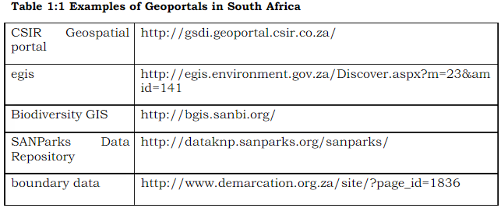

**Other geoportals**

* <http://www.naturalearthdata.com/>
* <http://worldclim.org/version2>
* <http://www.worldpop.org.uk/>
* <http://download.geofabrik.de/>
* <https://www.education.gov.za/Programmes/EMIS/EMISDownloads.aspx>

**1.4.4 Metadata**

It is important when searching for secondary data. Metadata can be used to evaluate the usefulness of geospatial data obtained from internet. It refers to information about data. Metadata files include the following:

* general descriptions about the contents of the file,
* spatial reference information
* definitions for the various terms used to identify records (rows) and fields(fields)
* the range of values for fields
* the quality or reliability of the data and measurements,
* how the data were collected
* when the data were collected
* who collected the data

**1.5** **Master input data list (MIDL)**

The master input data list (MIDL) is a detailed list of all the data sourcedatasets that need to be entered into GIS system to generate all the information products. A master input data list includes the following four components:

* Data identification details.
* Data volume considerations.
* Data characteristics.
* Data availability and costs.
  1. **REMOTE SENSING AS A SOURCE OF GEOGRAPHICAL DATA**
     1. **Benefits of Remote Sensing as a source of geographical data**
* In comparison to other methods such as field survey remote sensing ensures rapid collection of up to date data over large geographical area. For example a LANDSAT 5 TM scene measures approximately 170km north-south by 183 east-west. Thus data for such a large area can be obtained once through the use of satellite images.
* Also, remote sensing is the best data source to obtain data on regional phenomenon such as geological structure and forests. Remote sensing images are acquired by devices located above the earth surface hence provide an improved synoptic view of the earth surface features.
* Moreover, data is acquired by remotely operated sensors. Remote sensing is the only practical way of obtaining data from inaccessible regions such as the Antarctica and Amazon.
* Most of remote sensing data is acquired through space based satellite platforms. Each satellite as a temporal resolution or revisit period which refers to the number of days it takes before it acquires data at the same location again. Thus data for a certain location is acquired on a regular basis. Many geographical phenomenon exhibits temporal variations. Data acquired over several periods allow comparison of images hence revealing change.
* In addition remote sensing data is the optimum option for global studies as it provides a global data set of uniform quality. Remote sensing provide a uniform data set because images covering the earth surface acquired by the sensor. This will not be possible with field survey for instance.
* Remote sensing images are acquired over broad range of wavelengths allowing detection of certain phenomenon that will not be possible with the human eye. Images are acquired in the near infrared region and such wavelengths enables detection of unhealthy vegetation for instance which could not be done with the human eye.
* Furthermore, remote sensing is a popular data source for GIS because of systems such as RADAR. It supplies its own electromagnetic energy and operates in the Microwave region of the spectrum. Such systems are advantageous to field surveys for example as they can acquire data in a wide range of conditions. For example RADAR can acquire data at night and can be used to obtain data during severe weather conditions.

**1.6.2** **Image interpretation and analysis**

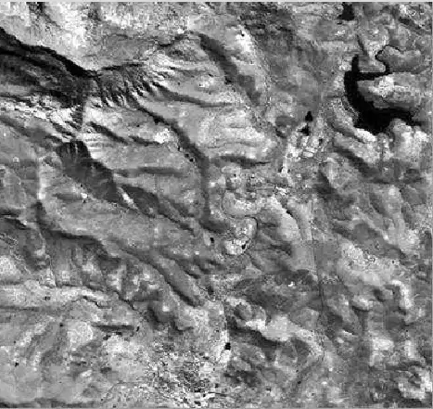

**Figure 1.1 LANDSAT 5 TM scene**

Above is a LANDSAT 5 TM scene covering the town of Alice and surrounding villages. The dark spots on the image are water bodies. Therefore, this image can be used to obtain data for water bodies such as area in hectares and/or simply locations of these water bodies. However, in order to take advantage of and obtain data that can be input into a GIS database, we must be able to identify features of interest and measure the required characteristics from the imagery. Data that will be put in a GIS can be extracted by visual interpretation or digital analysis methods from remote sensing images such as the one shown above.



**Figure 1.2 LANDSAT 5 TM scene zoomed**

The image above is a LANDSAT 5 TM scene that has been zoomed to show cell values. Note that scenes with different cell values have a different shade of grey. Higher cell values are characterized by brighter shades and scenes with low values are the darkest.

**1.6.2.1** **Visual interpretation**

Visual interpretation is performed manually or visually. It involves observing the differences between targets and their backgrounds. Data for various targets is acquired by comparing different targets based on any, or all, of the elements of visual interpretation. These include tone, shape, size, pattern, texture, shadow, and association.

**1.6.2.2** **Digital processing and analysis**

It requires image processing software. Digital processing may be used to enhance data as a prelude to visual interpretation. Digital image processing may involve numerous procedures including the following:

* formatting and correcting of the data,
* digital enhancement to facilitate better visual interpretation
* automated classification of targets and features

1. **DATA INPUT METHODS**

**2.1** **General remarks**

Data input methods refers to procedures that create digital spatial data. In other words, it refers to various mechanisms on which digital representation of spatial data such as roads, academic buildings and parking lots on campus are created. The digital representation of this spatial data is then stored in a GIS database. In the previous unit we were exposed to various data sources. In this unit we are going to explore how several data input methods create a digital representation of spatial data from various GIS data sources.

The diagram below helps to understand how digital representations of realword features are created.

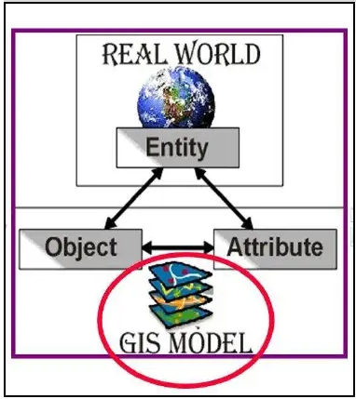

**Figure 2.1 Data modelling**

Importantly, the diagram clearly illustrates that a digital representation is created for a particular earth surface feature that is of interest to a specific GIS project. A GIS project at the University of Fort Hare might create a digital representation of academic buildings. This earth surface feature of interest to specific GIS project is known as an entity. A GIS database usually consists of several entities. In addition, on the diagram there are arrows pointing from entity label to object and attribute. The digital representation of the selected entity comprises of an object and attribute. Object refers to the graphical representation of an entity in a GIS database. Basic graphic representations of earth surface features are point, line or polygon. Attribute also known as non-spatial data is the characteristics of an entity selected for representation. Academic buildings at Fort Hare University can have attributes such as number of floors, name, number of lecture halls etc. Several entities are usually required to fulfil the needs of a GIS project. The digital representation of these entities as indicated on the diagram form a GIS model.

**2.2 Digitizing**

Digitizing is the process where features on a map or image are converted into digital format for use by a GIS. There are three primary methods for digitizing spatial information:

* Manual Methods include:
* Tablet Digitizing
* On screen digitizing /Heads-up Digitizing
* An Automated Method includes:
* Scanning

**To ensure that maps are digitized most efficiently and accurately, 4 steps need to be followed:**

1. Use good base maps

* The quality of the map manuscripts from which you digitize directly affects the accuracy of your digital data. You should always get the most reliable, most current maps possible.

1. Define your procedures

* Determine how the maps will be digitized.
* Establish a standard sequence of procedures, for example, you may want to digitize all the line coverage’s before the point coverage’s, etc.
* Establish a sequence for digitizing features and map sheets so you can track which portions of the database have already been digitized.
* Establish standard naming conventions.
* Establish schedules and shifts - digitizing is tiring work, so scheduling digitizing helps ensure accuracy, e.g. a schedule of 2 hours on, 2 hours off, might be appropriate.

1. Prepare your maps

* Map preparation helps minimize problems at the digitizing and editing phases.
* Overall, the goal is to minimize the number of times the person who digitizes and edits will have to stop work.

1. Digitize your maps

**2.2.1** **Tablet Digitizing**

Tablet digitising is done by placing a paper map on a digitising tablet andentering all the elements of the map into the data base by means of a sensitive digitizing puck. A digitizing tablet is a hardened surface with a fine electrical wire grid under the surface. The diagram below shows a digitizing tablet with a map prepared for digitizing.

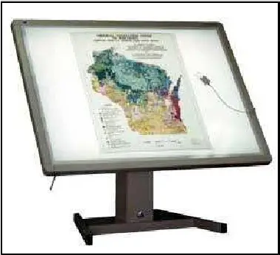

**Figure 2.2 Digitizing tablet**

A digitizing puck is an electrical device with cross hairs and multiple buttons to perform data entry operations.

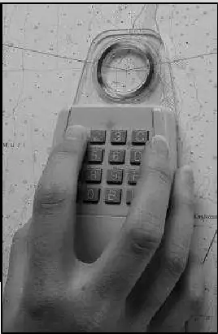

**Figure 2.3 Digitizing puck**

An operator enters data by placing the digitizing puck over the points on the map attached to the digitizing board and pressing different buttons on the puck, thus indicating the type of each point. A point can be either an individual element, or a part of a larger element such as a line or a polygon.

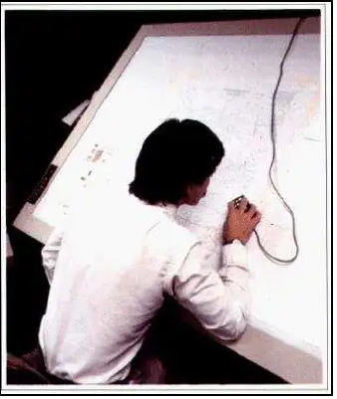

**Figure 2.4 Digitizing in action**

Lines and polygons are defined by a set of points (vertices) entered by an operator and chains/segments. Therefore, the accuracy of the data depends of the accuracy of the location of the points. In the case with lines and polygons, the more points entered, the smoother the curves of the line will appear.

**2.2.2** **On screen digitizing**

On screen digitizing is often called heads-up digitizing. It uses the computer mouse and digitizing software to manually trace the features on a source documents displayed on the computer screen. The source documents may be scanned images or digital aerial and satellite images. Most GIS software systems support on-screen digitizing. On-screen digitizing generally follows the steps below:

* Scan the source document into a digital image if paper map or aerial photo used.
* Add the image into a GIS
* Georeference the image
* Trace features on the image using the mouse
* Edit features
* Add attribute data

**2.2.3** **Data Elements Created**

* Digitizing point features is simply the process of creating a single point feature with an x, y coordinate. In most cases to create a point you first left click and then right click to make the point permanent.
* Digitizing lines involves creating a line feature that consists of a node (start and end) and a series of vertices which indicate a change of direction along that line. Straight features require fewer vertices; curved/complex features require more vertices.

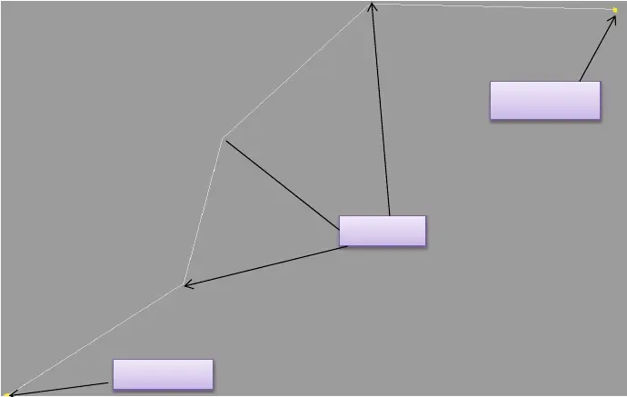

* Digitizing Polygons involves creating a set of connected lines. Polygons have single start-end node and vertices in between. Similar to lines polygons have vertices at every location where its boundaries change direction

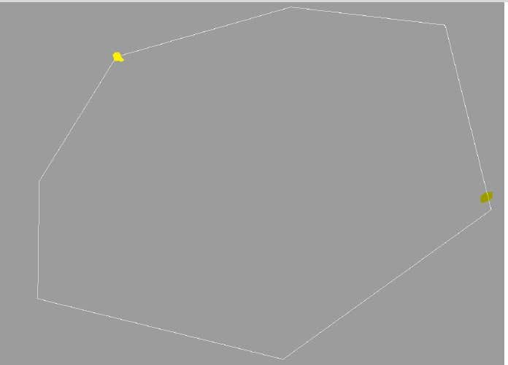

**Figure 2:5 Polygons**

**2.2.4** **Digitizing curved lines**

The diagram below illustrates how curved lines are digitized to preserve their properties. On a curved line change of direction is very abrupt and this can be preserved by inserting many vertices close together to capture the changes indirection. On the diagram it is shown that if a curved line is digitized with a few vertices it will not represent the earth feature accurately as it will not show the curvature of a river for an example. In addition zooming in may be required to digitize a curved section accurately.

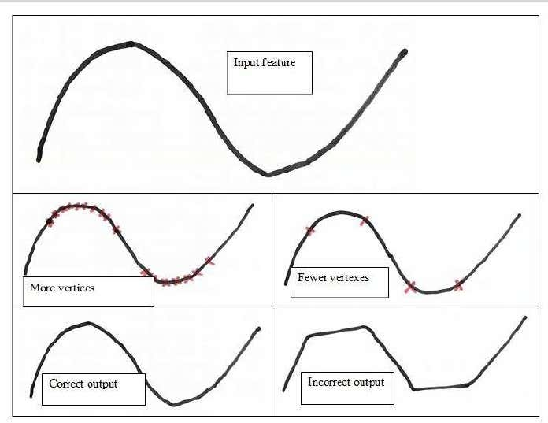

**2.2.5 Advantages of manual digitizing**

* The ability to correct errors or distortions in the original maps at the time of data capture.
* Highly reliable human recognition of map objects.
* The ability to interpret ambiguous or incomplete information and selectthe relevant required information at the time of data capture.
* Can be performed on inexpensive equipment;
* Requires little training

**2.2.6** **Disadvantages of manual digitizing**

* Manual digitizing labor intensive and therefore very time-consuming and costly.
* The quality of results is highly dependent on the operator experience.
* The results may be inconsistent due to varying operator conditions, stress, and fatigue.

**2.3** **Scanning**

Scanning is also known as automated digitizing. Hardy copy documents are converted into digital images with a scanner. Scanning produces a digital image of the map by recording amount of light reflected by the surface of the map. Common types of scanners are flatbed scanners and rotating drum scanners. If good source documents are available, scanning can be an efficient time saving mode of data input.

**2.3.1 Flat-bed scanner**

A flatbed scanner is usually composed of:

* a glass pane,
* bright light which illuminates the pane,
* and a moving of photo detectors On a flat-bed scanner the map is placed on a flat scanning stage. They are mainly used for small format maps and aerial photographs.

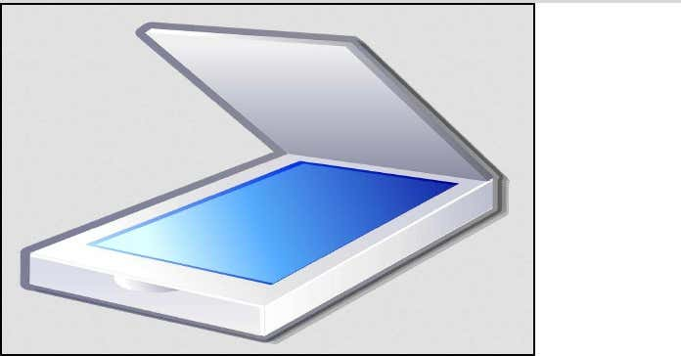

**Figure 2.6 flat-bed scanner**

A flatbed scanning involves an array of photo detectors which extract data from several rows of the raster simultaneously. The detectors move across the map in a swath. When all the columns have been scanned, the detector moves to anew swath of rows.

**2.3.2** **Drum Scanner**

The map is mounted on a cylindrical drum which rotates while the detectormoves horizontally across the map. As the drum rotates about its axis, a scanner head containing a light source and photo detector reads the reflectivity of the target graphic band digitizing this signal. It creates a single column of pixels from the graphic at time. The scanner head moves along the axis of the drum to create the next column of pixels, and so on through the entire scan.

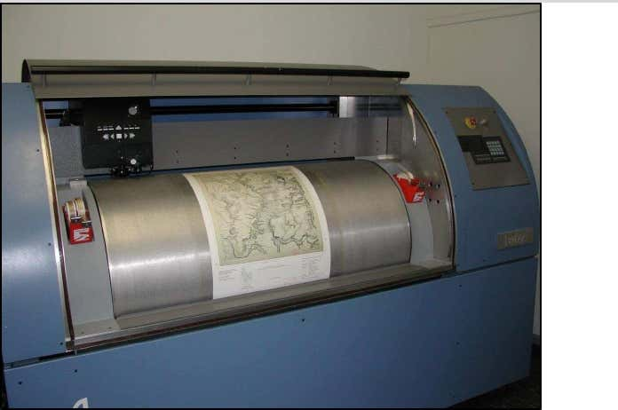

**Figure 2.7 Drum Scanner**

**2.3.3** **Requirements for scanning**

* Documents must be clean (no smudges or extra markings)
* Lines should be at least 0.1 mm wide
* Complex line work provides greater chance of error in scanning
* Text may be accidently scanned as line features
* Contour lines cannot be broken with text
* Automatic feature recognition is not easy (e.g. contour lines vs. road symbols) diagram
* Special symbols (e.g. marsh symbols) must be recognized and dealt with

**2.3.4** **Scanning - limitations**

* Requires expensive equipment,
* Involves expert personnel,
* Usually entails considerable editing
* Needs clean maps with well-defined lines
* Produces large quantities of data

**2.4** **Input of existing digital data**

It is becoming increasingly popular. In some cases, geo-portals may have a variety of spatial data that can fill some of the needs of a project. If the data was created using different software, a translation must occur to exchange the data and put it into a suitable format. Several ad hoc standards for data exchange have been established in the market place. GIS vendor’s have developed and provide data exchange/conversion software to go from their format to those considered common in the market place. Data transfer relies on the exchange of data in mostly proprietary file formats, using the import/export functions. Integrating these heterogeneous data sources requires considerable knowledge of GIS data-integration methods to produce a complete and seamless digital database

**2.4.1** **Problems associated existing digital data.**

* Software developers are reluctant to publish the exact file formats their systems can handle. Therefore, import routines are sometimes unstable and frequently lose some of the information contained in the original data files.
* Another set of problems are encountered due to lack of metadata or incomplete metadata. As a result, it is difficult to assess the quality of the digital information for instance. Also missing information about the geographic reference framework might make it impossible to convert data from the external data set’s coordinate system to the one used by the organization.
* Challenges to using existing data to construct GIS data base may occur due to differences in the data itself. These differences can arise due to variations in definitions and coding schemes. The use of different cartographic reference systems. Incompatible spatial scales and varying accuracy standards, which may result in features that should match across two databases being displaced.

**Questions**

1. Briefly explain the different types of Primary and Secondary data sources for GIS. 3-4
2. What are the available Geo-portals and what are the process to obtain from those geo-portals? 3-4
3. Mention some data inputs methods for GIS. 3-4
4. Write different steps to ensure maps are digitized most efficiently and accurately. 2
5. Definition:
6. Tablet Digitizing
7. On screen digitizing
8. Flat-bed scanner
9. Drum Scanner